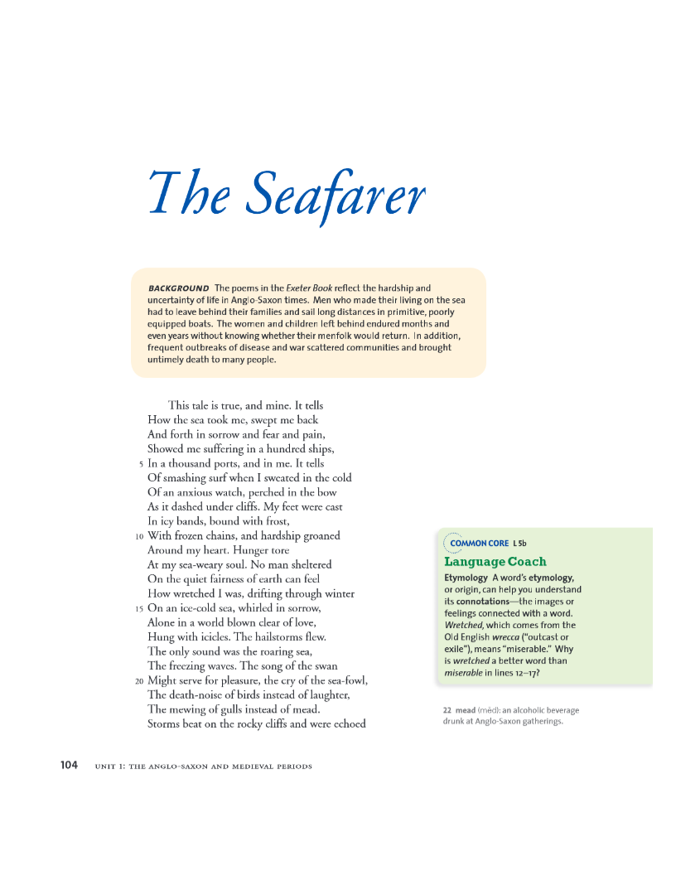Machine generated alternative text:
fly icy-fetihercd terris and the eagle’s screanis;
2 No kinsman could offer comfort there,
To a sutil leFt drowning in desolation. O
And who could believe, knowing but
Tite jiissiuli uíciIie, swelled proud widi wine
And no taste of misfortune, how often, how wearily,
.30 I fuit myself hack on tite p;itlis of lite sea.
Night would blacken; it would snow from the north;
Frost hound the earth and hail would fall,
‘lhc coldest seeds. And how my heart
Would begin to bear, knowing once more
3 ‘l’he salt waves tossing and the towering sea!
The time for journeys would come and my soul
Called me eagerly out, sent me over
The horizon, seeking foreigncrs homes.
But t here isll’l a litait on earth M) proud,
40 So born to greatness, so bold with his youth,
(;row,, so brave, or su graced by (od,
‘Ihat he feels no fear as the sails unfurl,
Wondering what Fate has willed and will do.
No harps ring in his heart, no rewards,
4 Analyze Visuals
Describe the mood of this
photograph as well as
those on pages tog and
113. What teatu res of cad,
landscape determine
its rrood?
24 tetne ea birds similar to gulls.
o IMAGERY
In lInes 12—26, wtiat senses does the
imagery appeal to? Describe the
mood rrralrd by the imagery.
TIlE SEAtAILIrIS 105

Machine generated alternative text:
45 No passion for wotnì. no worldly pleasures,
Not hiug. ouly the ocean’s heave:
But longing wraps itself around him.
Orchards blossom, the tous bloom.
Fields grow lowly as the world springs frcslL
50 And all these aduionisli that willing mmd
Leaping to journeys. always set
In thoughts traveling on a quickiizig tide.
So summer’s serthnel. the cuckoo, sings
In his iiiuiiiiittñuig  aH(l OW hearts moUnt
55 As he urges. Who could understand.
In inoiant ease, what we others suffer
As the paths of exile stretch erdless1y ou’Ø
And yet my heart wniiders away,
My soul roams with the sea, the wiiale
60 Home. wandering to the widest corners
Of the sotld. rdurniug rauious with desire,
Flying solitary screaniing, exciting me
To the open ocean. breaking oaths
On the curve of a wave.
Thus (he joys of God 
65 Are fervent with life, where life itself
Fades quickly into the earth. The wealth
Of the world neither reaches to Heaven nor remains.
No niait has ever faced the (lau
Certain which ofFates three threats
Would 1h11: illness, or age. or an inýs
Sword. suatching the life from his soul.
The praise the living p0111 on the dead
Flowers from reputation: plant
An earthly life of profit reaped
is Even front hatred and rancor, of bravery
Flung in the devil’s flice. and death
Cati only bring you earthly itse
And a song to celebrate a place
With the angels, life etually blessed
so In the hosts of I-leaven
The days ate gone
When the kingdoms of earth flourished in glory
Now thee aie no iule,s no iipei vi s,
No givers of gold. as once there we.
When wondeiftil things were sot’ked aiiiong theiui
ss And they lived in lordly iiiagnificence
Those poweis have vattished. those pleasures are dead.
The weakest survives and the surld coutúiues.
Kept spinning by toil. All glory is tarnished.
tO admonish (nJ-minltšh) o-iticlzeor
(Sution
53 jiiirri šnl riil (slThI?f-nH), th
cuckoo summer5jurd or walchmiwi
The cri e5ot cudcoos are cunimon in
Birope insurnmer, but in autumn the
birds migrate soutn
O IMAGERY
Note how the images in lines
4457eeatrast with thelmages of
theses. How Isthe speaker affected
by thoughts of lïfe on land?
O MONITOR
Noticethe break at line 64. Here
the speaker turns to a new dea.
How do you interpret the sentence
beginning ihusthejoysof God .?
80 hoso1 i’kven bands nl anq.s
106 unit j: the anal o-saxon and medieval periods